(Note that the Identification number is unique)

Problem 1
Musicana records have decided to store information on musicians who perform on their albums in a database. The company has wisely chosen to hire you as a database designer.
- Each musician that is recorded at Musicana has an ID number, a name, an address (street, city) and a phone number.
- Each instrument that is used in songs recorded at Musicana has a unique name and a musical key (e.g., C, B-flat, E-flat).
- Each album that is recorded at the Musicana label has a unique title, a copyright date, and an album identifier.
- Each song recorded at Musicana has a unique title and an author.
- Each musician may play several instruments, and a given instrument may be played by several musicians.
- Each album has a number of songs on it, but no song may appear on more than one album.
- Each song is performed by one or more musicians, and a musician may perform a number of songs.
- Each album has exactly one musician who acts as its producer. A producer may produce several albums.

Design a conceptual schema for Musicana. Be sure to indicate all keys and cardinality constraints and any assumptions that you make.
ERD 1_Solution
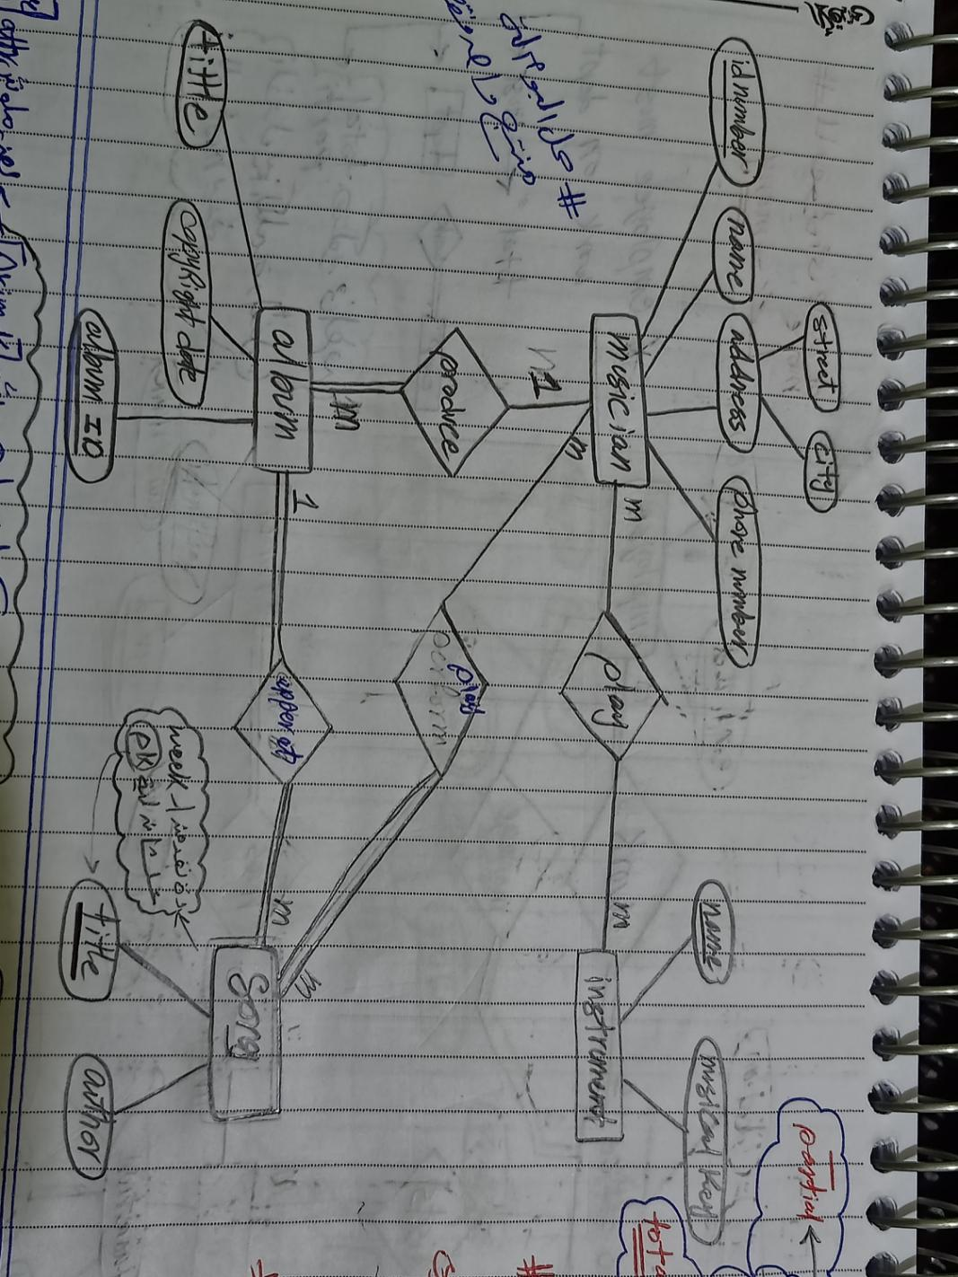
Problem 2
Prepare an E-R diagram for a real estate firm that lists properties for sale. The following describes this organization:u6 m
  - The firm has a number of sales offices in several states. Attributes of sales office include Office_Number and Location.
  - Each sales office is assigned one or more employees. Attributes of employee include Employee_ID and Employee_Name. An employee must be assigned to only one sales office.
  - For each sales office, there is always one employee assigned to manage that office.
  - The firm lists property for sale. Attributes of property include Property_ID and Location. Components of Location include Address, City, State, and Zip_Code.
  - Each property must be listed with one (and only one) of the sales offices. A sales office may have any number of properties listed, or may have no properties listed.
  - Each property may have zero or more owners. Attributes of owners are Owner_ID and Owner_Name. An owner may own one or more properties. The system stores the percent owned by each owner in each property.
ERD 2_Solution
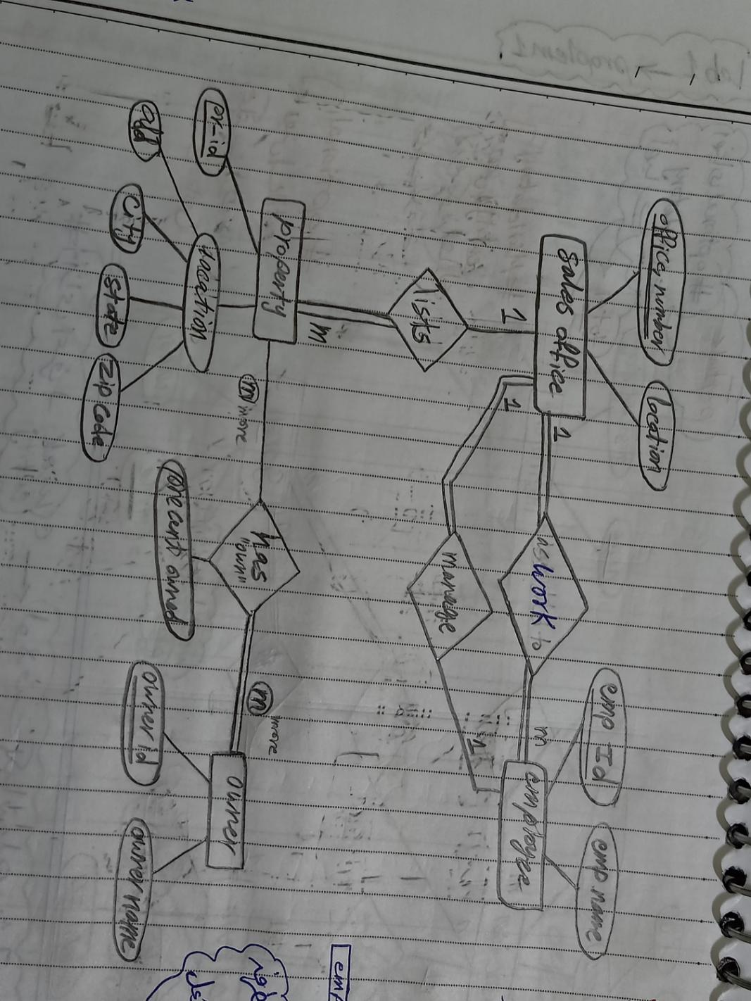
Problem 3
- A General Hospital consists of a number of specialized wards. Each ward is described by ward_id, Name
- The system records the following details about patients: Patient_id, name, Date_Of_Birth
- Each ward may host zero or more patients and each patient is hosted by only one ward.
- Each patient is assigned to one leading consultant but may be examined by other consultants, if required.
- Each consultant may be assigned zero or more patients and may examine zero or more patients.
- Consultants are described by Consultant_id, Name
- The system has to record all required data each time the Nurse gives a patient a certain drug with specified dosage at certain date and time.
- Each ward is under supervision of one nurse and a nurse may supervise only one ward.
- Each Nurse must serve in one ward
- Data about the nurse is recorded as her name and her number and her address.
- A drug has code number, recommended dosage and more than one brand name
ERD2_Solution
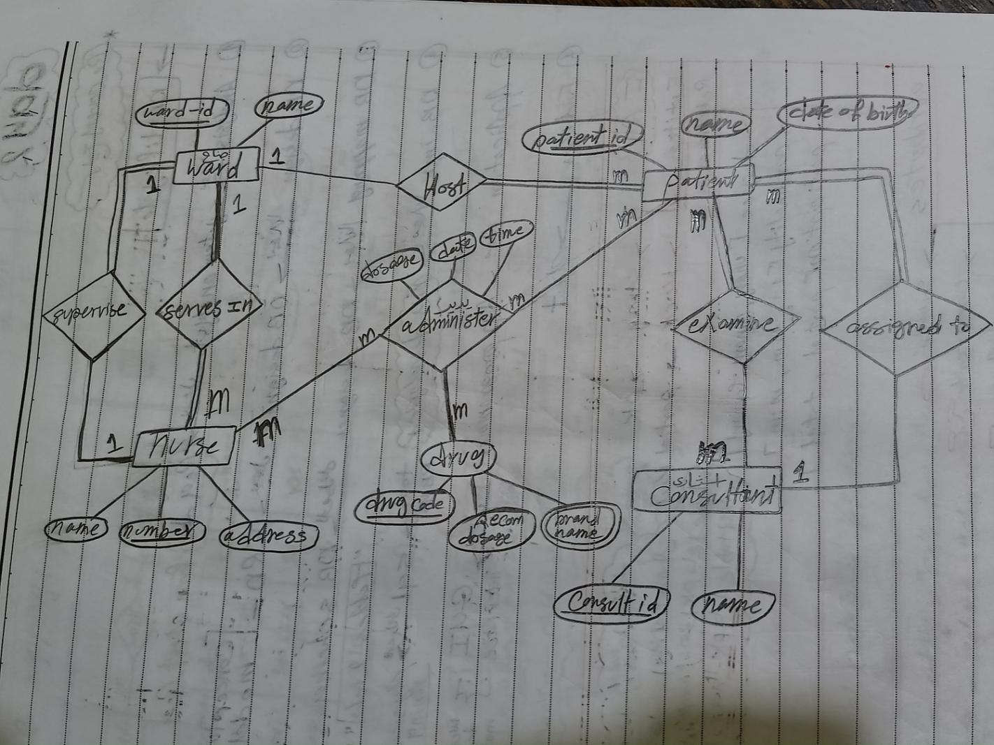

Problem 4
Major airlines companies that provide passenger services keep database with lots of information on all airlines.
1. Each airline has an identification number, name and address, name of the contact person and telephone numbers.

2. Each employee works in Airline Company has an employee identification number, name, address, birthday recorded as (day, month, year), gender, position with the company, and qualifications.

3. Each airline owns different aircraft models. For each aircraft an aircraft identification number, capacity, and model is recorded.

4. The aircrafts are assigned to different routes. An aircraft can work on more than one route and a route has many aircrafts going on it. Some information as number of passengers, price per passenger, departure date time, arrival date time and the time that aircraft spent in travelling the route are recorded.

Each route has a route identification number, origin, destination, distance,classification (e.g. domestic or international route).

5. Each aircraft has its own crew (major pilot, assistant pilot and two hostesses), the aircraft crew not stored as employee. Each crew is assigned to one aircraft.

6. Each airline keeps information about their buy/sell transactions (for example selling an airplane ticket is a sell transaction, paying for maintenance is a buy transaction). Each transaction has a transaction identification number, date, description, and amount of money paid/received.
Draw an E-R diagram for the database presented above.
ERD 4_Solution
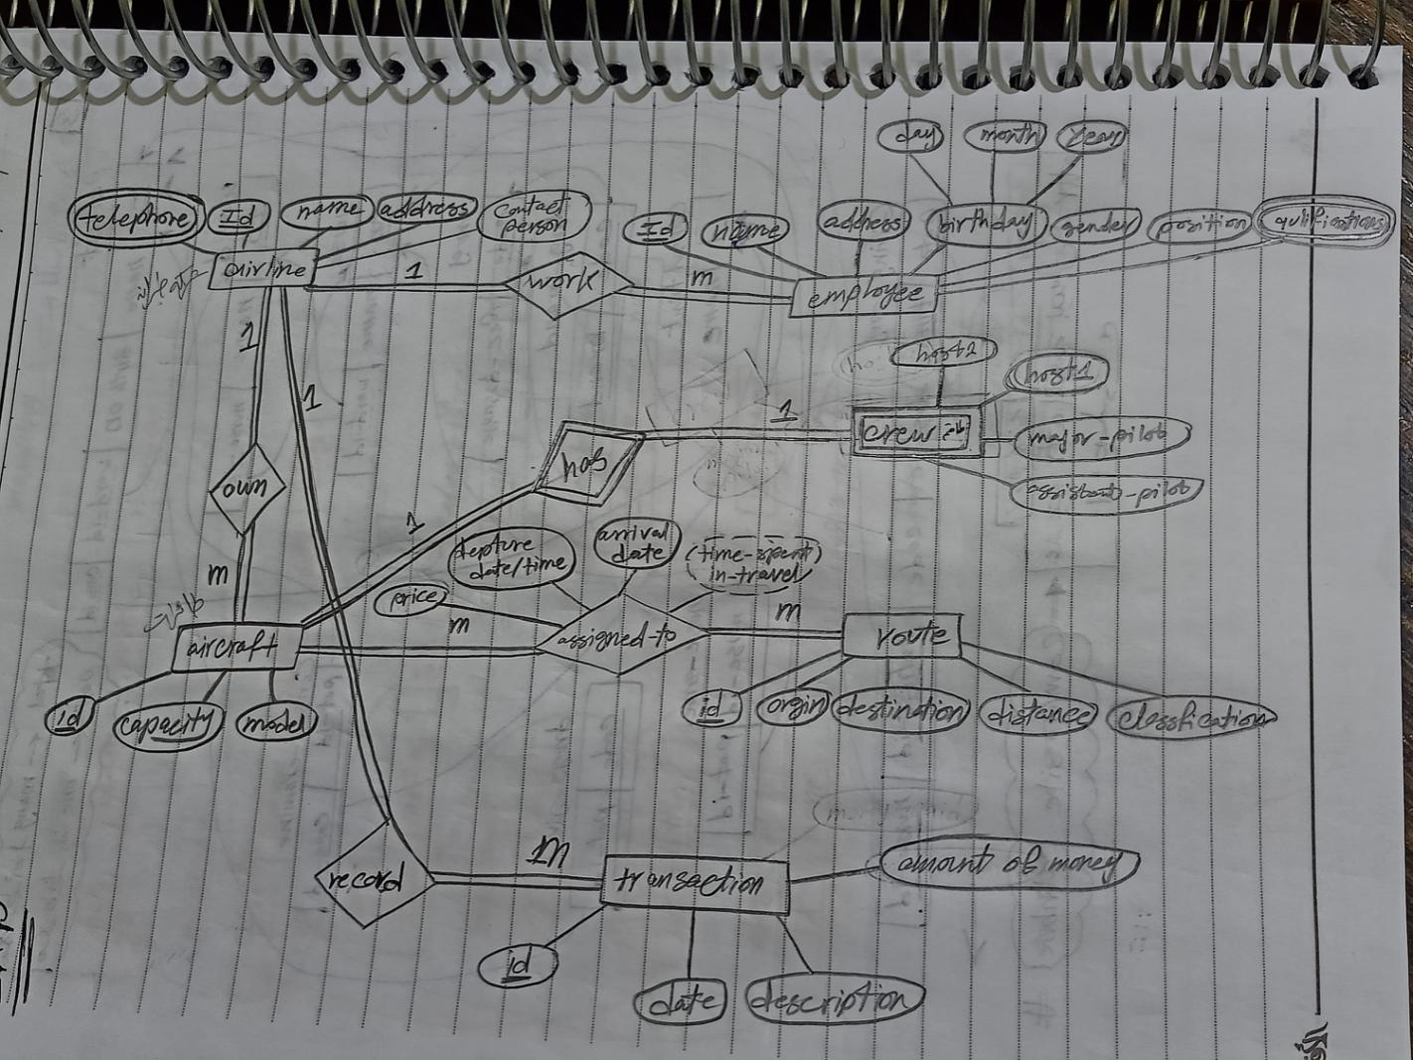
Day 1 Done

